Annual Update for Emergency Cards

Dear Parents,

Welcome back to another exciting school year in Chandler Unified School District. This year we will be doing our emergency card updates online. Below are step-by-step directions and screen shots should you need any assistance. Please note that you will need to complete every pleat of every section in order to update your emergency card.

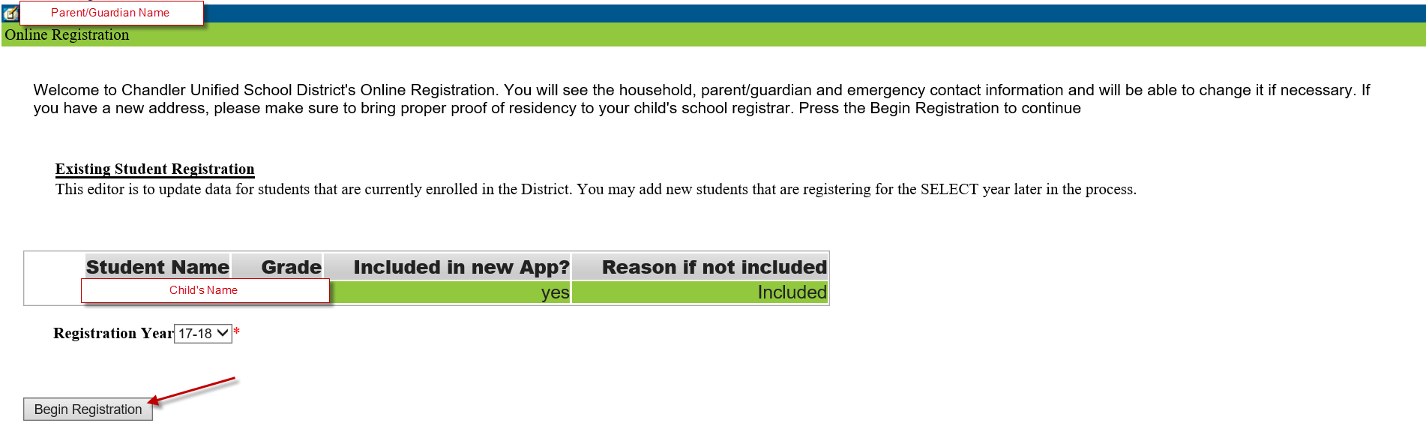

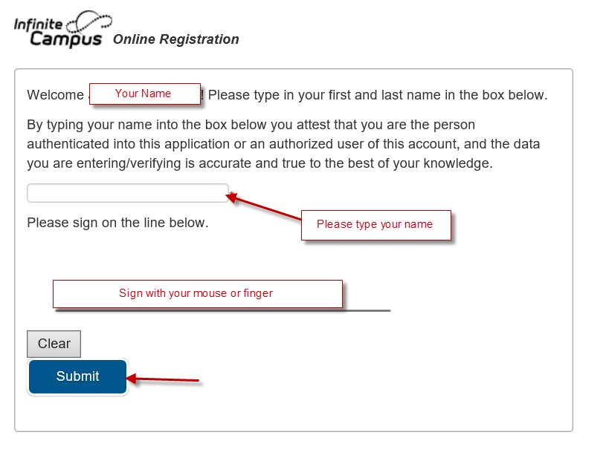

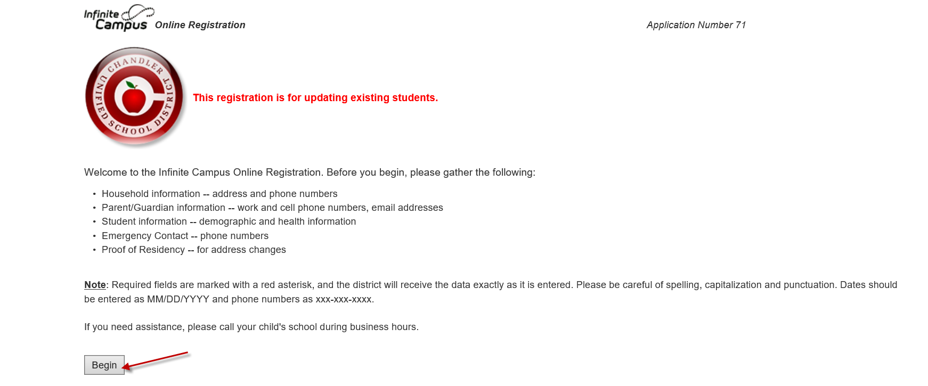

Friendly Reminder:

There are three pleats in Student(s) Primary Household section. Each pleat must be looked at in order to save and continue to the next section.

Pleat 1: Home Phone

Pleat 2: Home Address

Pleat 3: Mailing Address

**Student(s) Primary Household Section**

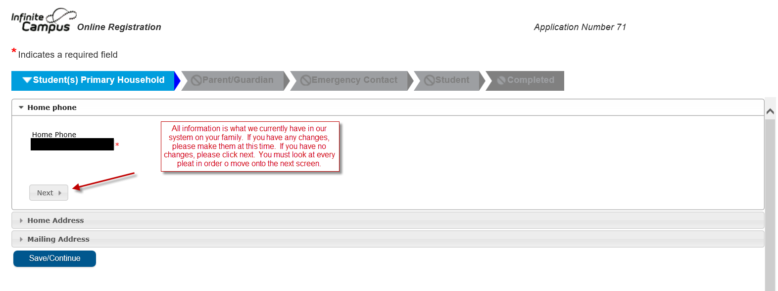

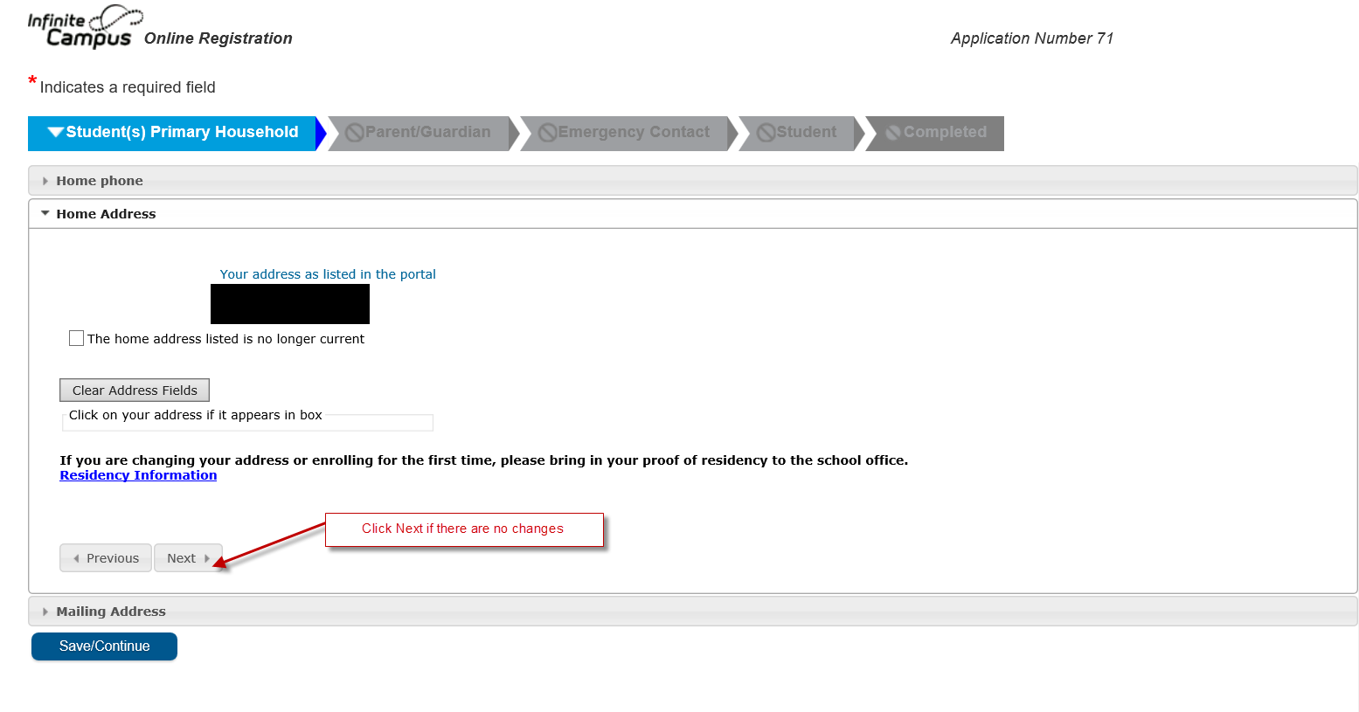

If you have moved over the summer, please provide proper documentation to your child’s registrar. Your application cannot be approved until they have received your proof of residency.

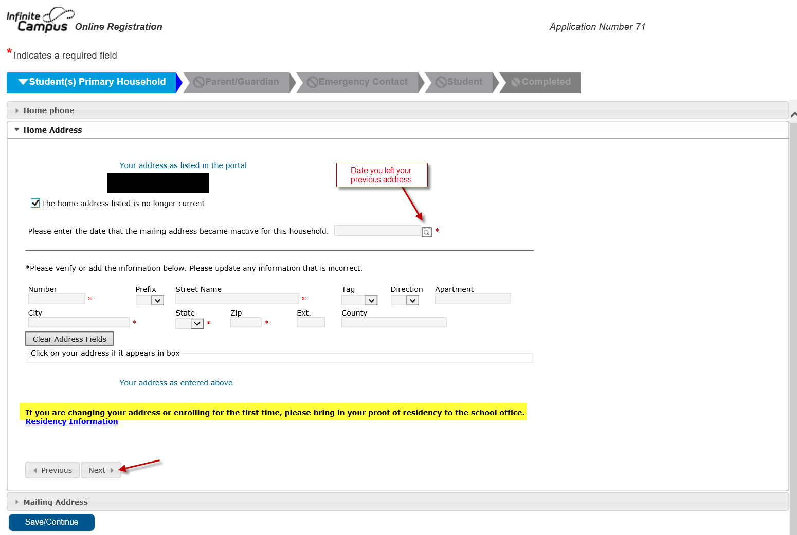

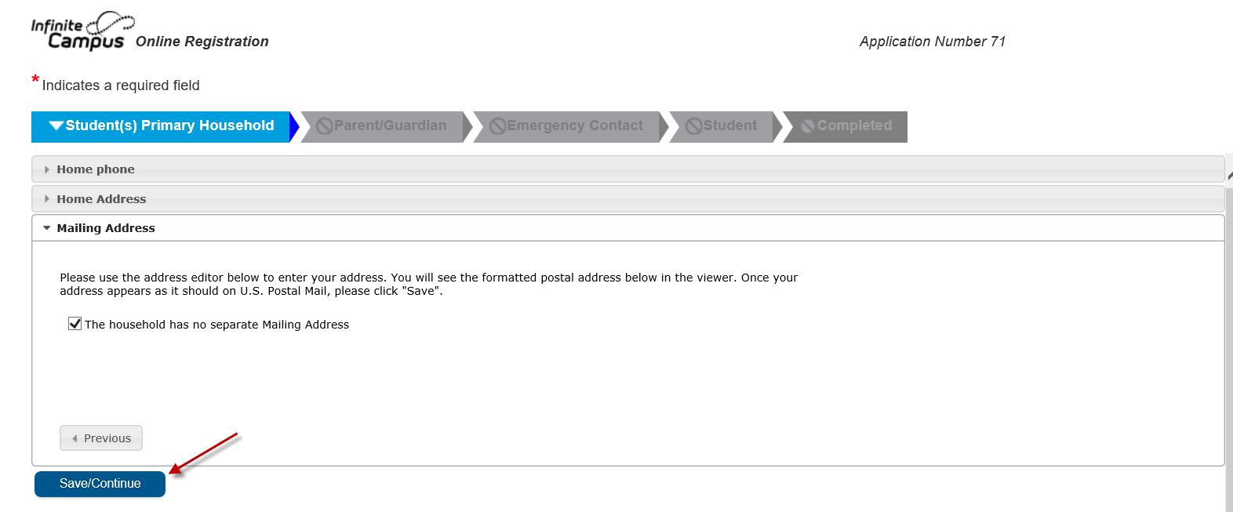

Only uncheck the household has no separate mailing address checkbox if you would like your mail to be delivered elsewhere. Please enter the information as accurately as possible. Please use proper abbreviations and capitalization. It is important to us to get information sent to you in a timely manner.

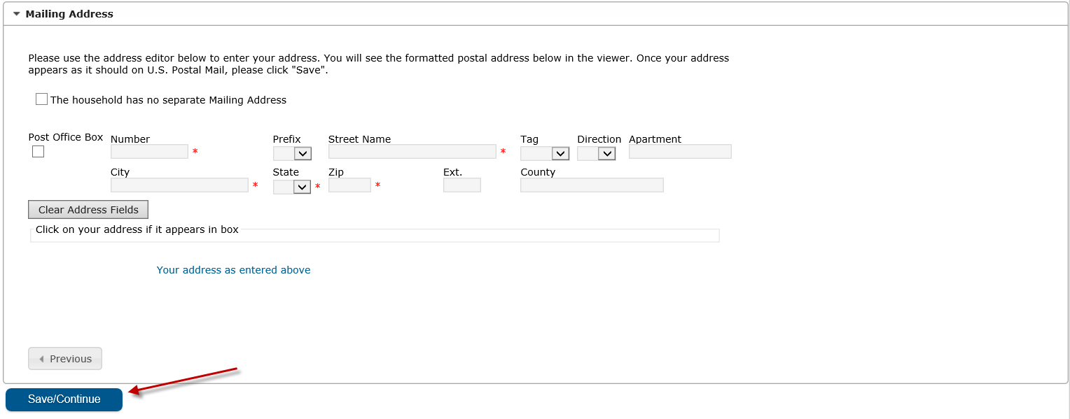

**Parent/Guardian Section**

All areas highlighted in yellow will need your attention.

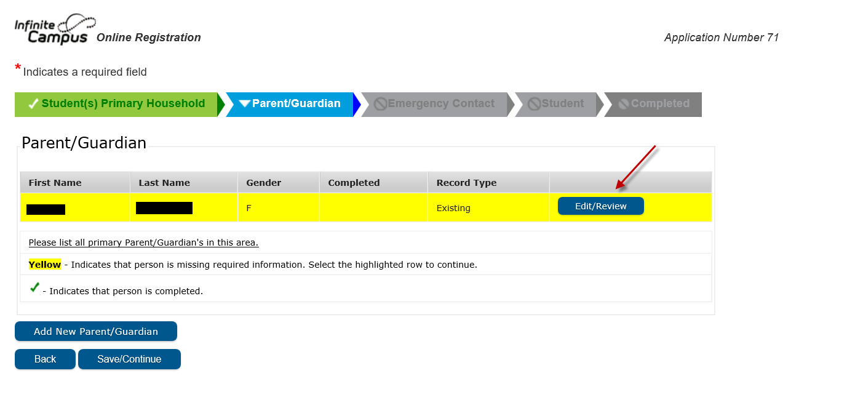

Information that has been auto populated has been imported from what you have previously provided to your child’s school.

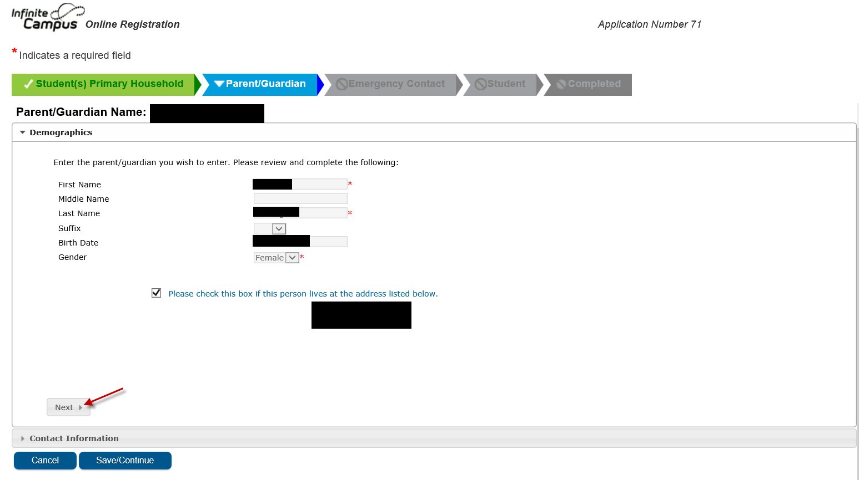

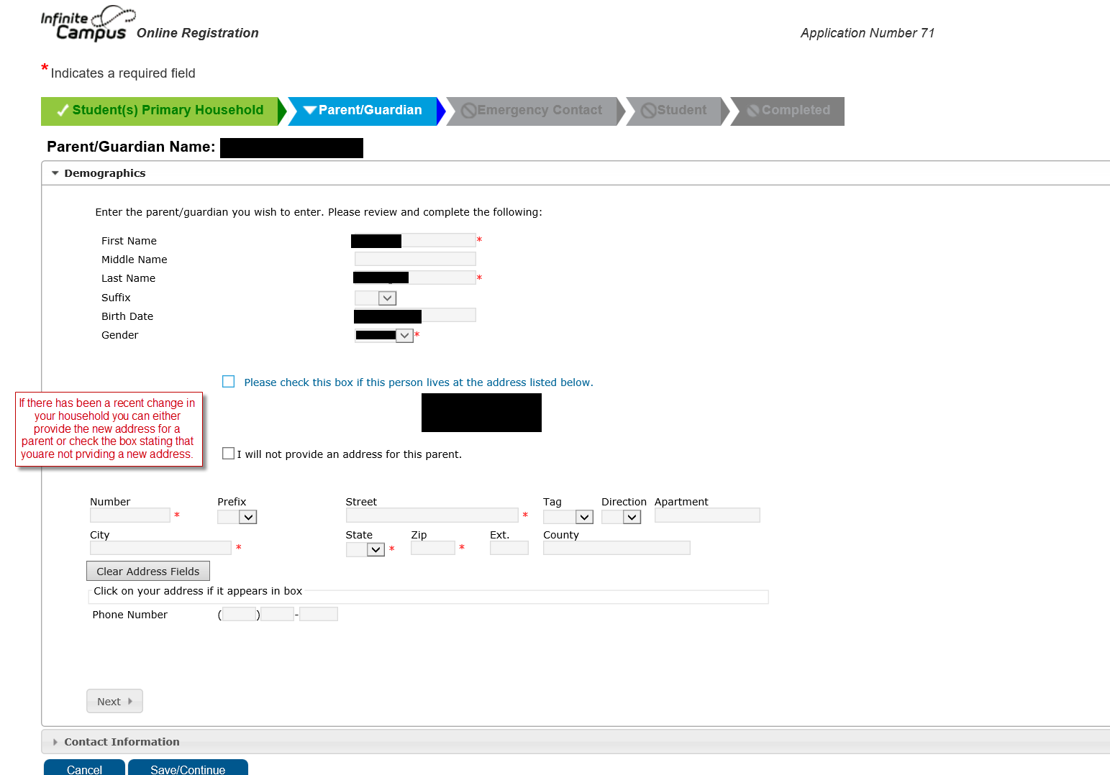

It is important for us to have at least one parent email on file.

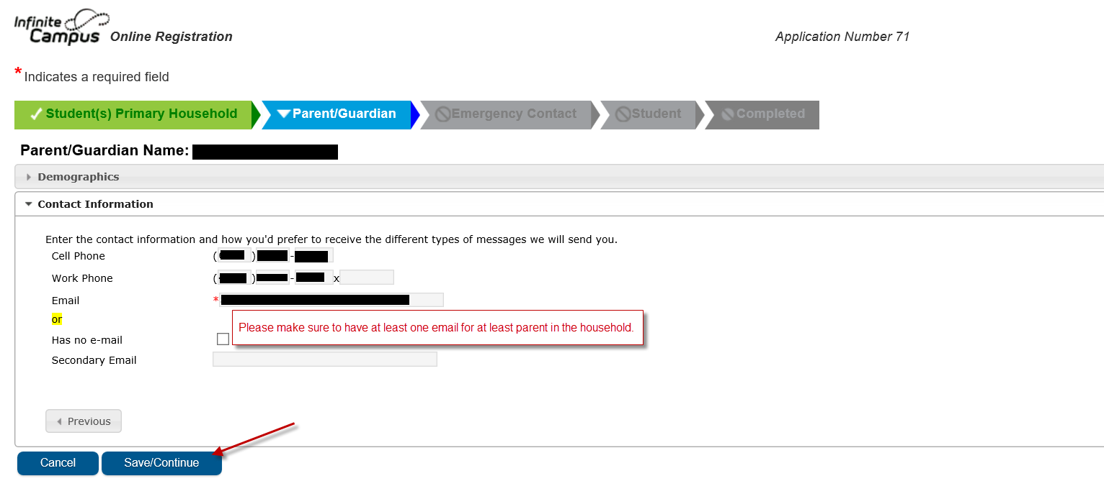

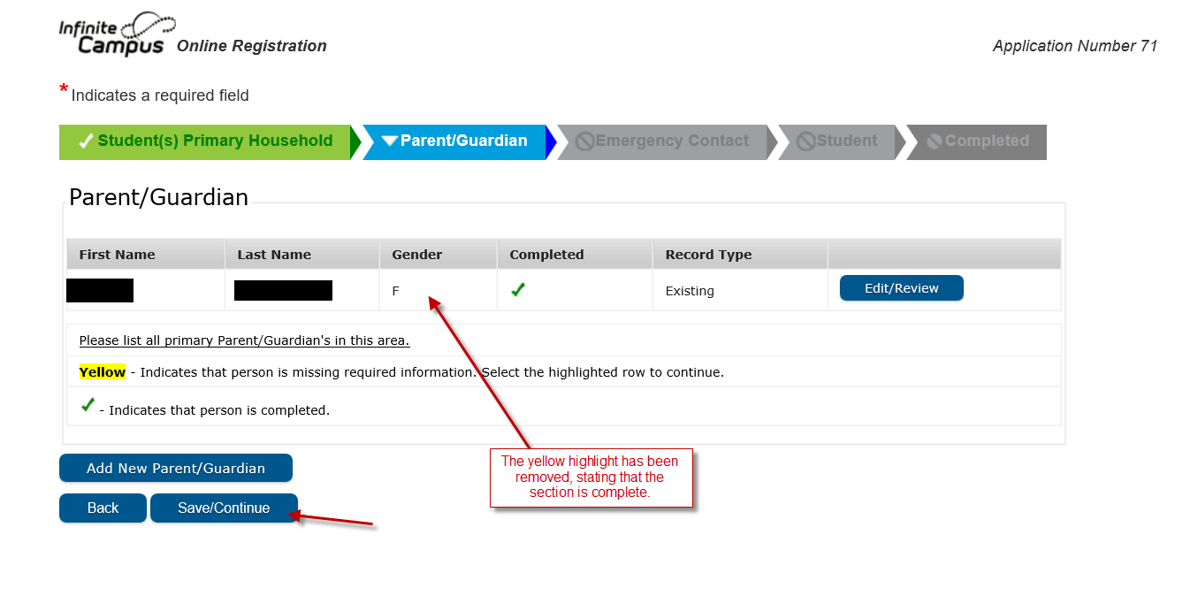

**Emergency Contact Section**

You can add and remove emergency contacts. Please make sure to have at least one emergency contact on file if we are unable to reach a parent or guardian.

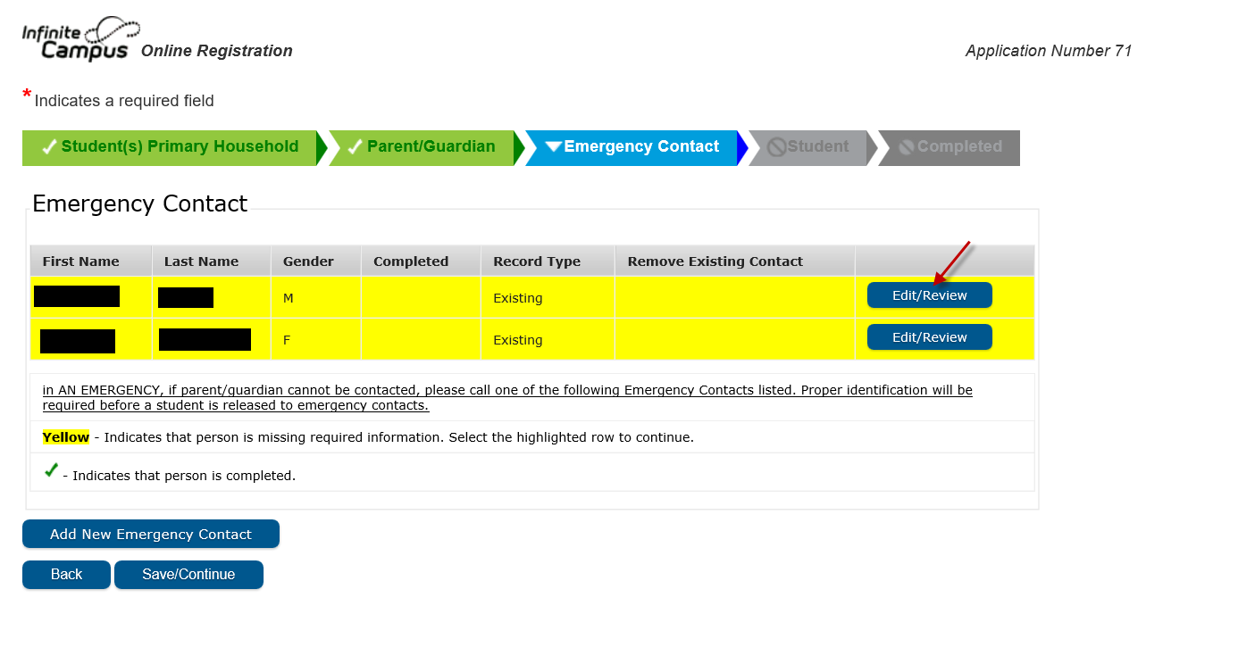

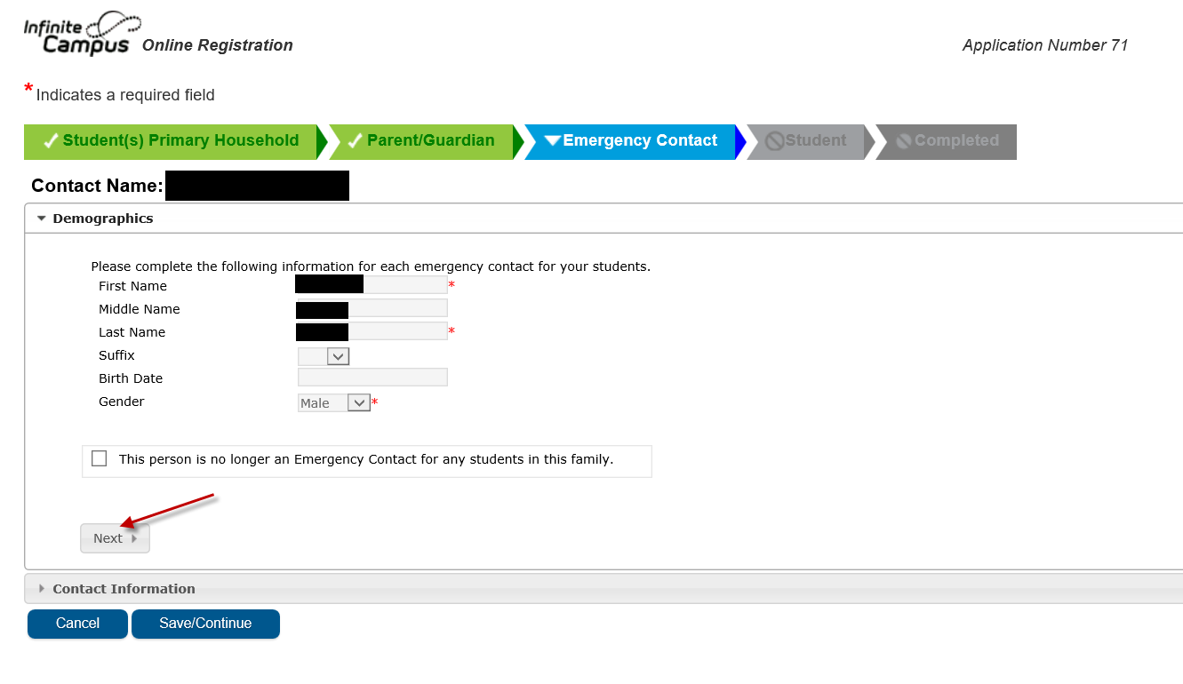

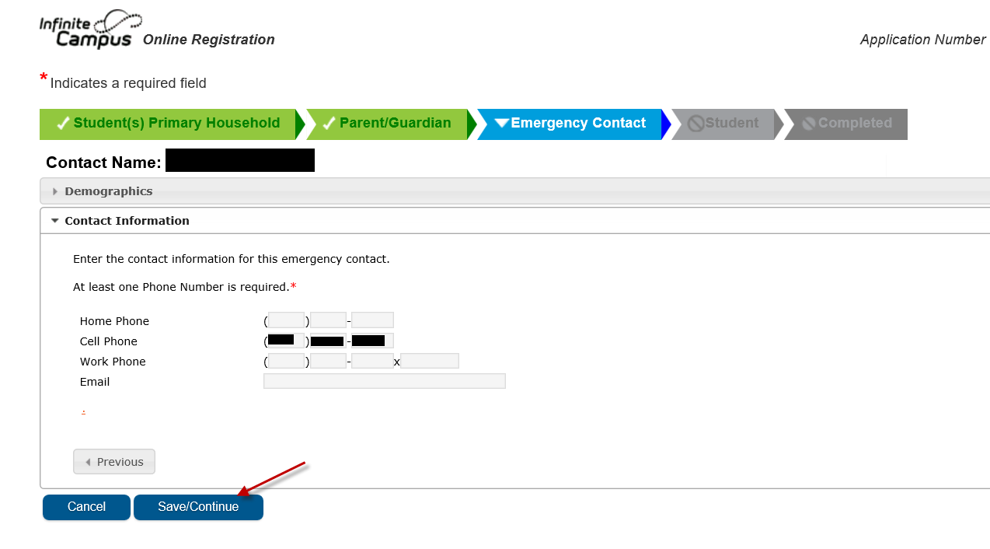

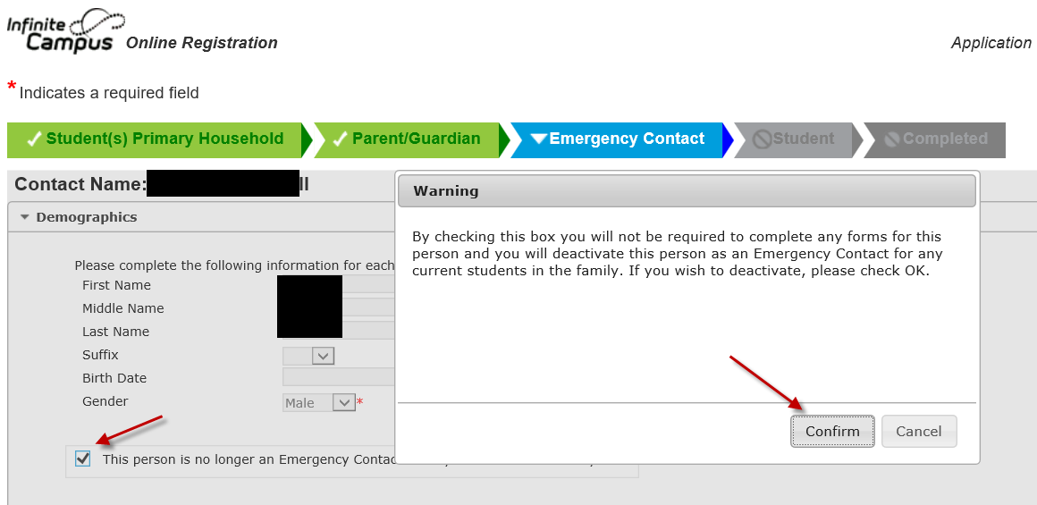

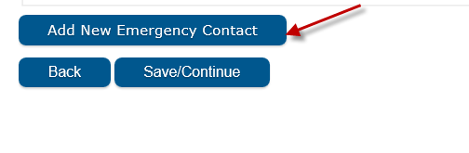

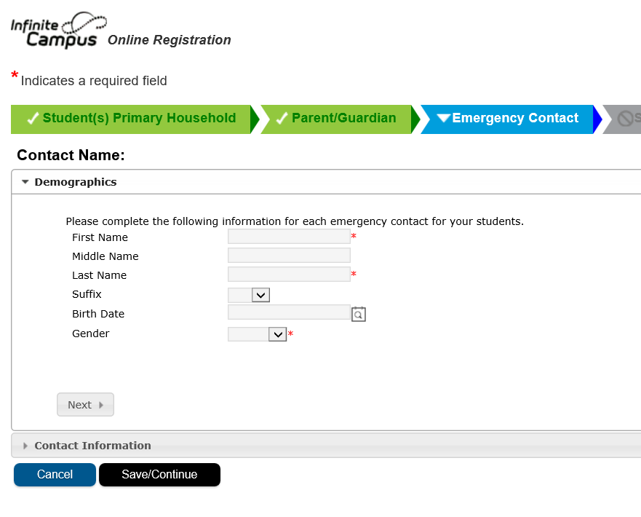

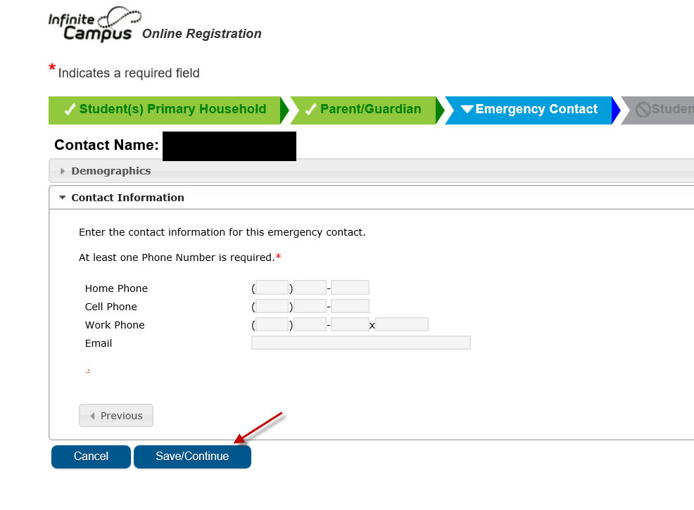

**Student Section**

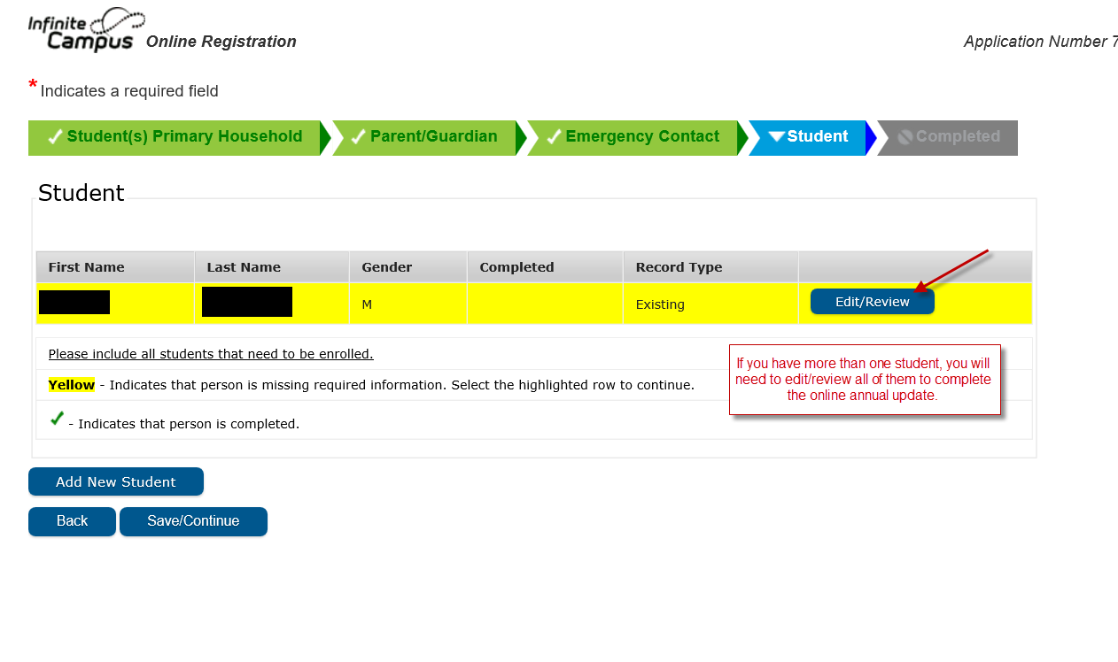

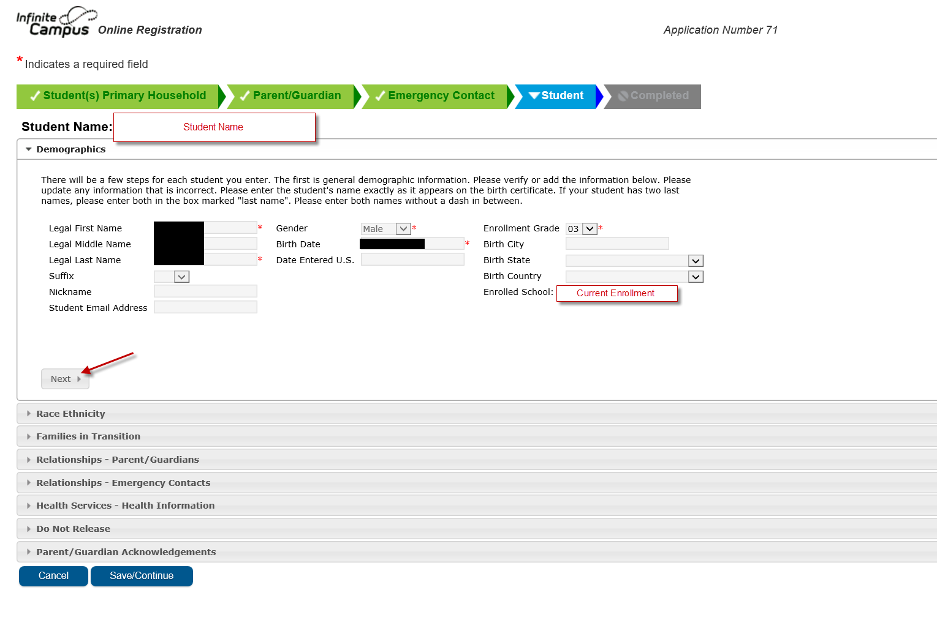

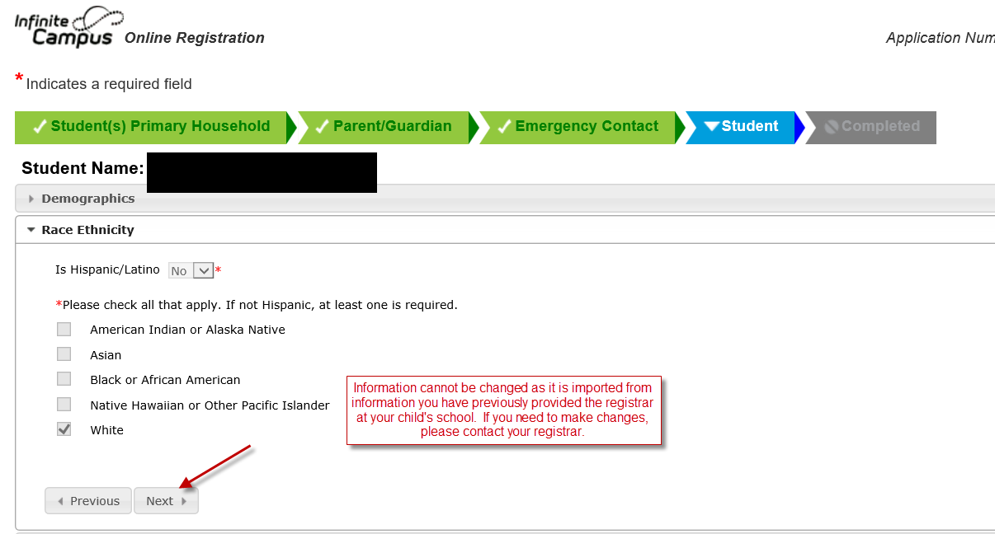

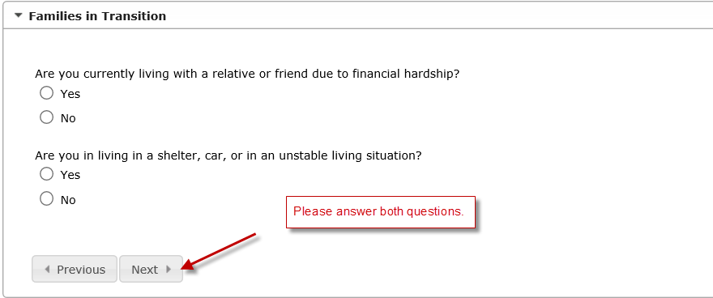

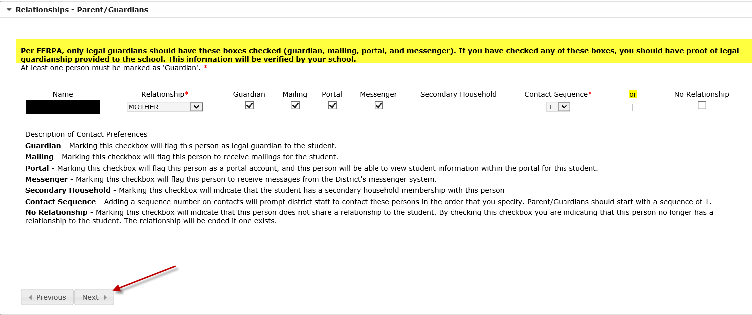

Contact Sequence:

1-4 Parent or guardian

5 and higher Emergency Contact

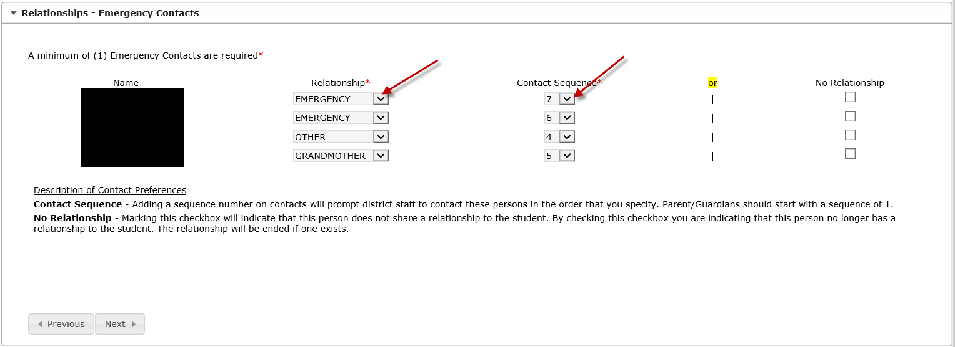

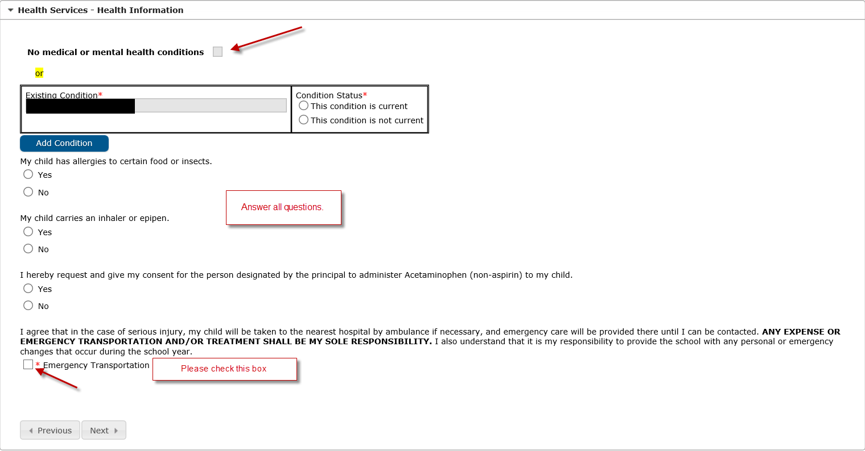

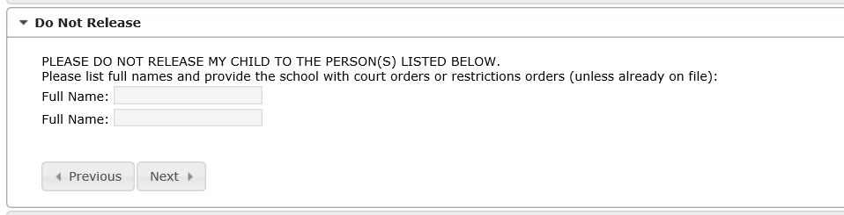

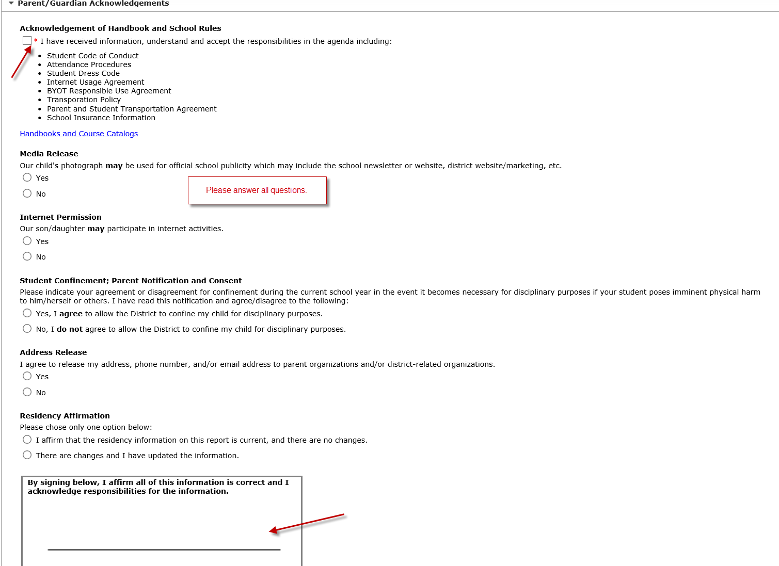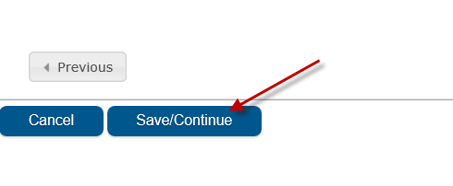

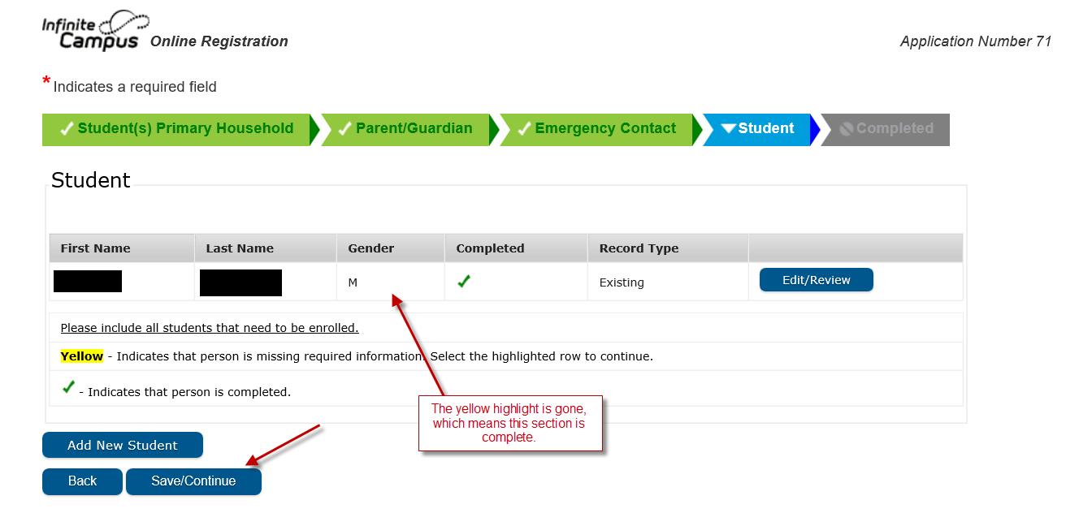

**Completed Section**

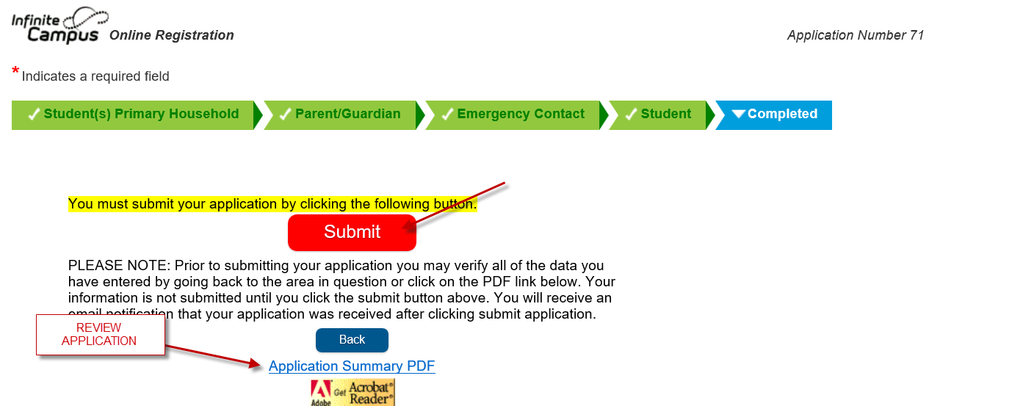

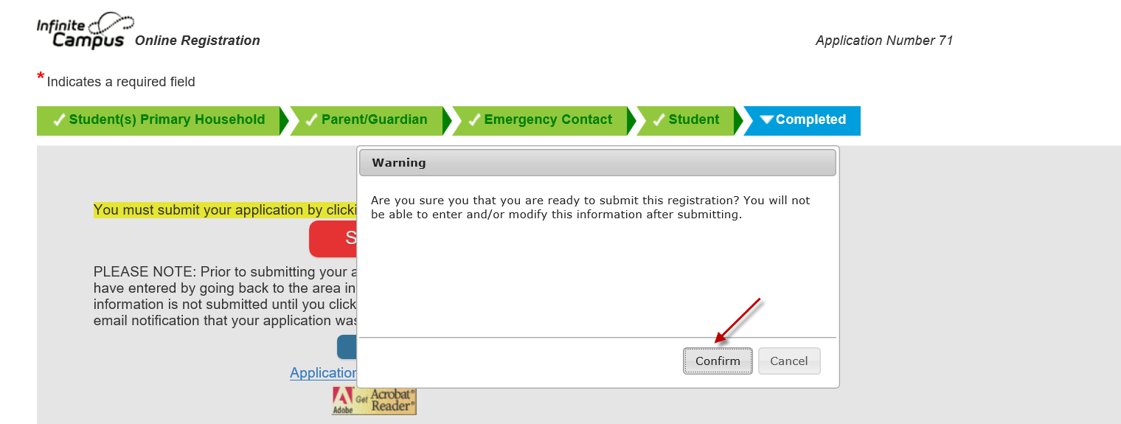

If you would like a copy of your application summary click on the PDF link when you get to the last page.

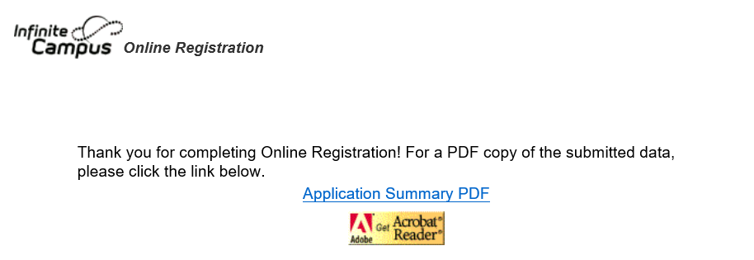

Once you submitted your application, you will receive an email that it has submitted. Please do not reply to this email. If you have any questions, please contact your child’s school. You will be updated through email as the registrar goes through all of the applications once the update window is closed. Should you have any changes after the window closed, you will need to go into your child’s school and provide those details.

